Table of Content

Chapter One | Introduction 1

1.1 Project Overview 1

1.2 Document Overview 1

1.3 Work Products to be Develop 2

1.4 Acronyms and Definitions 2

Chapter Two | Infrastructure 3

2.1 Software Development Life Cycle 3

2.2 Software Acquisition Plans 4

2.3 Hardware and Material Resources 4

Chapter Three | Management Procedures 5

3.1 Project Team Structure 5

3.2 Monitoring and Controlling Mechanism 5

3.2.1 Software Development Model 5

Chapter Four | Quality Plan 6

4.1 Quality Factors 6

4.2 Reviews/Responsibility 7

4.3 Testing 7

4.4 Software Development Standard 7

Chapter Five | Estimated Duration of Tasks 10

# Chapter One | Introduction

## Project Overview

Emergency Information on Mobile provides user application and admin webpage. The application will show online map and offline map. User can views the information of each help place on the map and call directly from the application. The admin webpage uses to manage the information such as add, edit information and delete help place out of the database.

* + 1. **Purpose & Scope**

Emergency Information on Mobile will support online map and offline map to help people about the information of the help pace. The application will provide the offline map with information around the user when they lost Internet connection.

## Document Overview

The purpose of the Emergency Information on Mobile project plan is to guide project team members during the development of Emergency Information on Mobile project.

**Progress Report I** consist of

**• Feature 5:** Manage Information System

[URS-1]: The administrator can add help information, which includes name, address, district, province, zip code, phone number, category, latitude and longitude.

[URS-2]: The administrator can edit help information, which includes name, address, district, province, zip code, phone number, category, and coordinates location.

[URS-3]: The administrator can remove help location.

[URS-4]: The administrator can view help information of each help place.

[URS-5]: The administrator can browse the help location by help place category.

[URS-6]: The administrator can browse the help location by province of Thailand.

• **Feature 1:** Map and Help Information System

[URS-7]: The user can view the online map with their current location.

[URS-8]: The user can view the offline map with their current location.

[URS-9]: The user can view the help place around user’s current location in online map.

[URS-10]: The user can view the location of help place in offline map.

[URS-11]: The user can view help information of each help place in online map.

[URS-12]: The user can view help information of each help place in offline map.

[URS-13]: The user can make emergency call to each help place

[URS-14]: The user can make emergency call to each help place.

## Work Products to be Develop

|  |  |  |  |  |
| --- | --- | --- | --- | --- |
| **No.** | **Deliverables/Release** | **Media** | **No. of Copies** | **Date** |
| 1 | **Project Proposal**  • Emergency Information On Mobile  Version 1.0 | Document | 3 | 5th March 2014 |
| 2 | **Progress Report I**  • Project Management Plan Version 1.0  • Software Requirement Specification  Version 1.0  • Software Design Document Version 1.0  • Test Plan Version 1.0  • Traceability Record Version 1.0  • Software Version 1.0 | Document | 3 | 28th May 2014 |

**1.3.1Deliverable**

## Acronyms and Definitions

**1.4.1 Acronyms**

EIOM Emergency Information on Mobile

SRS Software Requirement Specification

URS User Requirement Specification

**1.4.2 Definition**

…

# Chapter Two | Infrastructure

## 2.1 Software Development Life Cycle

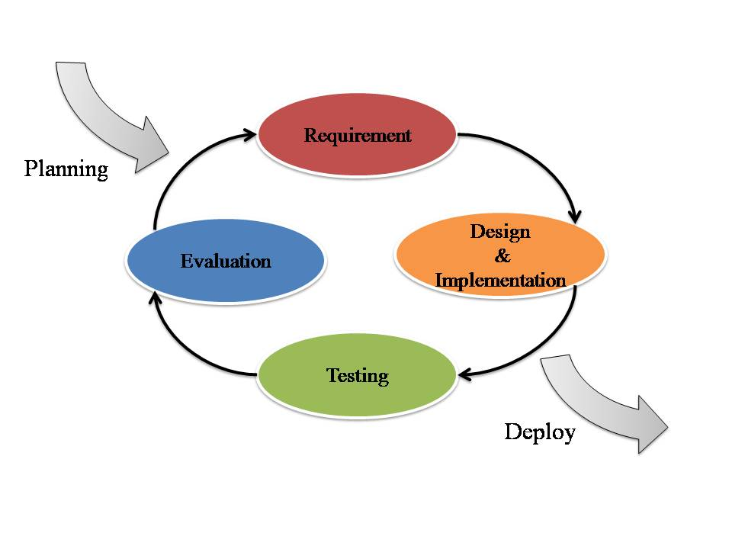

**Figure 1 Iterative Development Model**

Figure 1 presents a method of software development. Iterative development model is a cyclic software development process developed in response to the weaknesses of the Waterfall model. The model starts with planning and continues through iterative development cycles.

Emergency Information on Mobile use Iterative Development Model. Developer can use model to develop the iterative way to fulfill, change software and document for each development process.

## 2.2 Software Acquisition Plans

**2.2.1 Design Tools**

* Photoshop CS6
* Adobe Dreamweaver CS6

**2.2.2 Development Tools**

* Eclipse Kepler
* IntelliJ 12.1.6

**2.2.3 Configuration Management Tools**

* GitHub

**2.2.4 Document Tools**

* Microsoft Word 2013

**2.2.5 Testing Tools**

* Smart Phone Samsung (Android Device)
* Notebook with Google chrome or Firefox browser
* Host Server

## Hardware and Material Resources

• Computer

* Dell Inspiron N 5110
* Apple macbook pro mid 2013

• Internet

• Mobile Phone: Android Operating System

* Samsung galaxy S DUOS

# Chapter Three | Management Procedures

## 3.1 Project Team Structure

|  |  |  |
| --- | --- | --- |
| **Participants** | **Roles** | **Responsibility** |
| Putchakarn Jaikon  and  Sawatdiporn Kitirot | • Developer  • Tester  • Reviewer | •         Create document  - Proposal  - Project Plan  - SRS  - Software Design Document  - Test Plan  - Test Record  - Traceability Record  •         Develop software  •         Test software  •         Review document and software  •         Mange change |

## 3.2 Monitoring and Controlling Mechanism

### 3.2.1 Software Development Model

|  |  |
| --- | --- |
| **Participants** | **Roles** |
| Aj.Chartchai Doungsa-ard | Project Advisor |
| Putchakarn Jaikon | Development team member |
| Sawatdiporn Kitirot | Development team member |

# Chapter Four | Quality Plan

## 4.1 Quality Factors

**Product operation factors**

* **Correctness**
* The software product should able to provide more than 80% correctness of data from user traditional request.
* **Reliability**
* The software should able to handle more than 80% of traditional activity with less than 10% of software’s failure.
* **Integrity**
* The software should able identify between customer and seller.
* The software should able to limit a group of person who can modify the data.
* **Usability**
* The people who use software product, as his first time should able to use all features within 30 minutes.

**Product revision factors**

* **Maintainability** 
  + - The software should have 20-30% of comment comparing with the whole LOC to support the future maintenance activity.
* **Testability** 
  + - The software should able to be tested 100% of it defined routine and functionality.

**Product transition factors**

* **Reusability** 
  + - More than 20% part of finished software product should able to be reused in future development.

## 4.2 Reviews/Responsibility

|  |  |  |  |
| --- | --- | --- | --- |
| **Stage Exit Review** | | | |
| **No.** | **Stage** | **Review Item** | **Responsibility** |
| 1 | The progress report 1 | Project Plan | Putchakarn, Sawatdiporn |
| 2 | The progress report 1 | Requirement Specification | Putchakarn, Sawatdiporn |
| 3 | The progress report 1 | Architecture and Software Design Document | Putchakarn, Sawatdiporn |
| 4 | The progress report 1 | Software Testing | Putchakarn, Sawatdiporn |
| 5 | The progress report 1 | Traceability Record | Putchakarn, Sawatdiporn |

## 4.3 Testing

|  |  |  |
| --- | --- | --- |
| **Test Process** | | |
| **No.** | **Test** | **Responsibility** |
| 1 | Unit Testing | Putchakarn, Sawatdiporn |
| 2 | System Testing | Putchakarn, Sawatdiporn |
| 3 | Acceptance Testing | Putchakarn, Sawatdiporn |

## 

## 4.4 Software Development Standard

**4.4.1 ISO29110 for Very Small Entity (VSE)**

ISO 29110 is a guide applies to Very Small Entities (VSEs), enterprise, organization, department or project up to 25 people, dedicated to software development. The Guide provides Project Management and Software Implementation process which integrate practices based on the selection of ISO/IEC12207- Systems and Software Engineering –Software Life Cycle process – guidelines for the content of software life cycle process information products (documentation) standards elements.

1. **Project Management (PM) process** 
   * **PM purpose**

The purpose of the Project Management process is to establish and carry out in a systematic way the tasks of the software implementation project, which allows complying with the project’s objectives in the expected quality, time and costs.

* + **PM objectives**

**PM.O1:** The *Project Plan* for the execution of the project is developed according to the *Statement of Work* and validated with the Customer. The tasks and resources necessary to complete the work are sized and estimated

**PM.O2:** Progress of the project is monitored against the *Project Plan* and recorded in the *Progress Status Record.* Corrections to remediate problems and deviations from the plan are taken when project targets are not achieved. . Appropriate treatment is taken to correct or avoid the impact of risk. Closure of the project is performed to get the Customer acceptance documented in the *Acceptance Record*.

**PM.O3:** The *Change Requests* are addressed through their reception and analysis. Changes to software requirements are evaluated for cost, schedule and technical impact.

**PM.O4:** Review meetings with the Work Team and the Customer are held. Agreements are registered and tracked.

**PM.O5:** *Risks* are identified as they develop and during the conduct of the project.

**PM.O6:** A software *Version Control Strategy* is developed. Items of *Software Configuration* are identified, defined and base lined. Modifications and releases of the items are controlled and made available to the Customer and Work Team including the storage, handling and delivery of the items.

**PM.O7:** Software Quality Assurance is performed to provide assurance that work products and processes comply with the *Project Plan* and *Requirements Specification*

* + **PM Activities**

The Project Management Process has the following activities:

* + - PM.1 Project Planning
    - PM.2 Project Plan Execution
* PM.3 Project Assessment and Control
* PM.4 Project Closure

**2. Software Implementation (SI) process**

* + **SI purpose**

The purpose of the Software Implementation process is the systematic performance of the analysis, design, construction, integration and tests activities for new or modified software products according to the specified requirements.

* + **SI objectives**

**SI.O1:** Tasks of the activities are performed through the accomplishment of the current *Project Plan*.

**SI.O2:** Software requirements are defined, analyzed for correctness and testability, approved by the Customer, base lined and communicated.

**SI.O3:** Software architectural and detailed design is developed and base lined. It describes the software items and internal and external interfaces of them. Consistency and traceability to software requirements are established.

**SI.O4:** Software components defined by the design are produced. Unit test are defined and performed to verify the consistency with requirements and the design. Traceability to the requirements and design are established.

**SI.O5:** *Software* is produced performing integration of software components and verified using *Test Cases and Test Procedures*. Results are recorded at the *Test Report*. Defects are corrected and consistency and traceability to *Software Design* are established.

**SI.O6:** A *Software Configuration* that meets the Requirements Specification as agreed to with the Customer, which includes user, operation and maintenance documentations, is integrated, base lined and stored at the *Project Repository*. Needs for changes to the *Software Configuration* are detected and related *Change Requests* are initiated.

**SI.O7:** Verification and Validation tasks of all required work products are performed using the defined criteria to achieve consistency among output and input products in each activity. Defects are identified, and corrected; records are stored in the *Verification/Validation Results*.

* + **SI activities**

The Software Implementation Process has the following activities:

* SI.1 Software Implementation Initiation
* SI.2 Software Requirements Analysis
* SI.3 Software Architectural and Detailed Design
* SI.4 Software Construction
* SI.5 Software Integration and Tests
* SI.6 Product Delivery

# Chapter Five | Estimated Duration of Tasks

- **Server part**

**Feature5: Manage information system**

* Add help locations
* Edit help locations
* Remove help locations

- **Mobile part**

**Feature1: Map and help information system**

* View map and help locations
* View information of help locations
* Make emergency call

**Progress I**

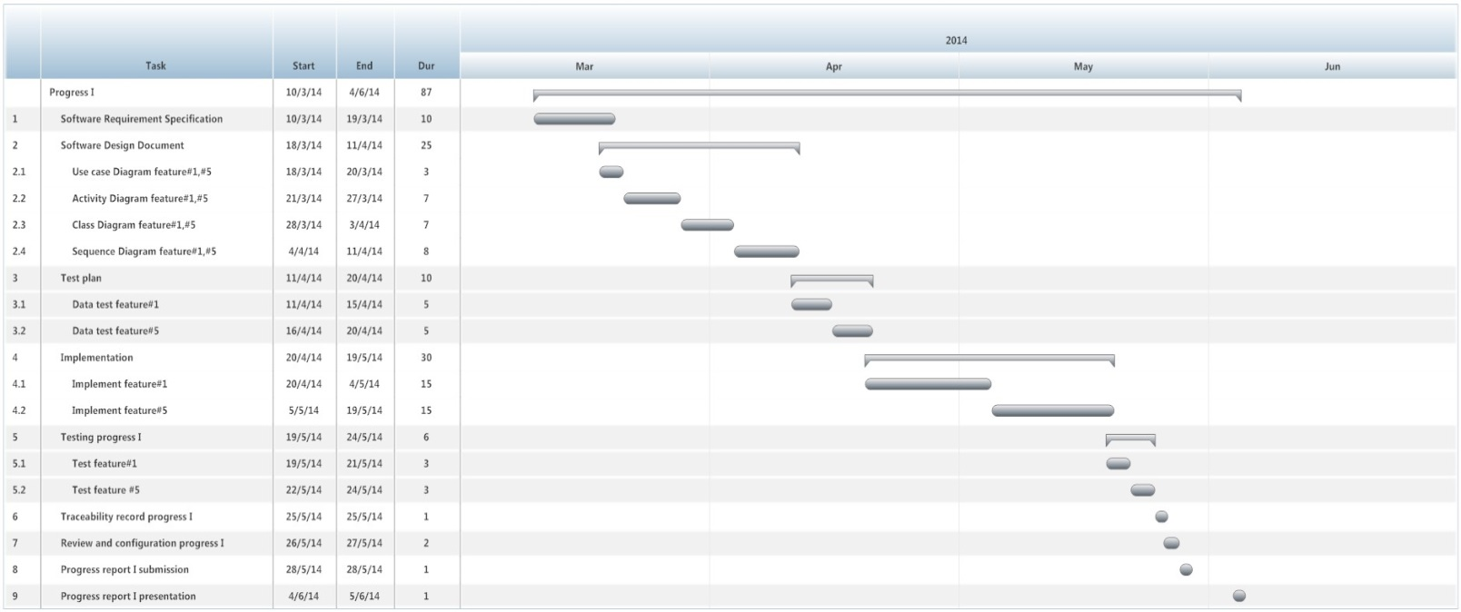

**Figure 2 Milestone of Progress Report I**

Figure 2 shows estimated duration of tasks in the progress report I